Table of Contents
Document Version 2
1. Purpose 3
1.1. Intended Audience 3
1.2. Intended Use 3
1.3. Scope 3
1.4. Definitions and Acronyms 3
2. Overall System Description 4
2.1. Use Case Diagrams 4
2.2. System Architecture 5
2.3. Functional Requirements 6
2.3.1. Function xxxx 6
2.3.2. Function yyyy 7
2.3.3. Function zzzz 7
3.1. Non-Functional Requirements 8
3.1.1. Non-Functional Requirement xxxx 8
4. Software Architecture 9
4.1. Static Software Architecture 9

Document Version
No | Update | Name | Date | Version
1. | Initial version | Draft 1 | 11/6/2025 | 1.0

Purpose

Intended Audience
This SRS document describes the System Requirements and Software Design for an IoT Vending Machine and the target audience are System and Software Engineers working on the development of this project.

Intended Use
The SRS defines the overall System Architecture and Requirements as well as the Software Architecture and Design. This document also contains the definition of the System Requirements which shall be used as the input for System Test cases and Software Unit Test cases.

Scope
This document defines the system and software requirements for an IoT-enabled vending machine, covering its functional and non-functional specifications. It serves as a comprehensive guide for system and software engineers to design, develop, and test the vending machine’s hardware and software components.

Definitions and Acronyms

Acronym | Description
IR | Infra Red
LED | Light Emitting Diode
LCD | Liquid Crystal Display
RFID | Radio-Frequency Identification
US | Ultrasound

Overall System Description

Use Case Diagrams
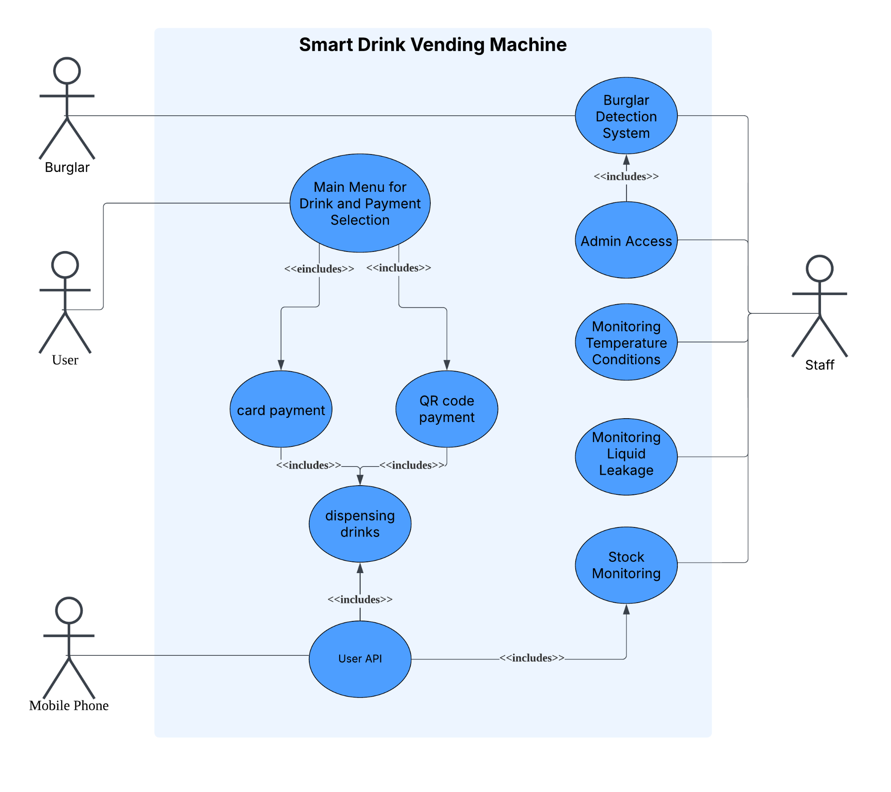

System Architecture

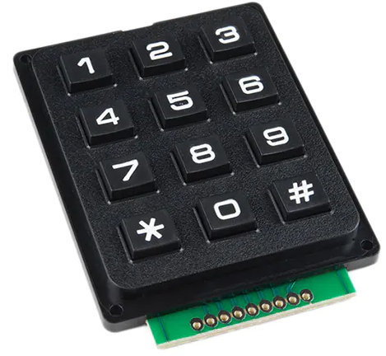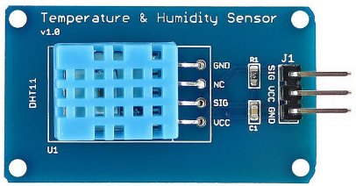

Moisture Sensor
Ultrasonic Sensor
IR Sensor
GPIO18
GPIO23
GPIO6, 20, 19, 13, 12, 5, 16
LED
GPIO24
DC Motor
Servo Motor
Buzzer
GPIO21
LCD
I2C
Raspberry Pi Development Board
RFID
GPIO26
GPIO25 GPIO27
GPIO17
GPIO4
GPIO7, 11, 9, 10

Camera
WiFi Module

Functional Requirements

Main Menu for Drink and Payment Selection

The Main Menu for Drink and Payment Selection allows users to choose a drink via keypad, view feedback on the LCD, and select a payment method. It checks drink availability and resets to the home screen after 30 seconds of inactivity.

REQ_ID | Requirement
REQ-1 | Upon powering on the vending machine, LCD shall display “Welcome, please” on line 1 and “ select a drink” on line 2. This will be the homescreen
REQ-2 | The keypad shall allow users to input numeric values of 0-9, and subsequently printed on the LCD. Once users press the ‘#’ button on the keypad, their selection is confirmed, ‘*’ allows the user to clear the LCD.
REQ-3 | After ‘#’ is pressed, the machine will check if the number has a drink assigned to it, and if there is stock for it.
REQ-4 | If the inputted number has no stock/no drink, the LCD shall display “Invalid, please” on line 1 and “try again” on line 2, allowing the user to retype the number.
REQ-5 | If the inputted number has stock for the drink, the LCD displays the name of their corresponding drink choice on line 1, and will display selected drink price on line 1 as well, along with “1=Card 2=QR Code ” on line 2. This is the payment option screen.
REQ-6 | If the keypad receives no activity after 30 seconds, return to the homescreen
REQ-NEW1 | If user presses * during payment option screen, return to the homescreen
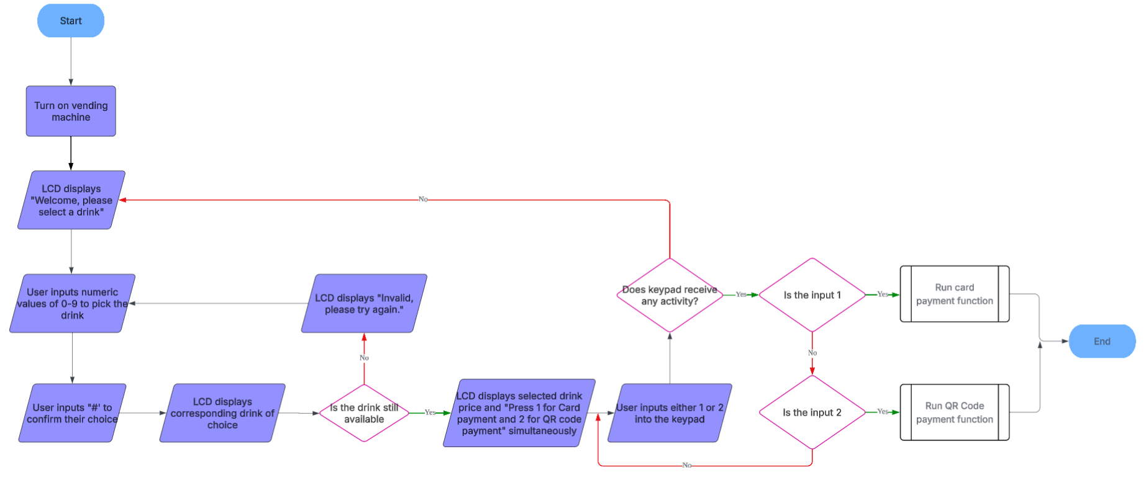
REQ-1
REQ-2
REQ-3
REQ-4
REQ-5
REQ-6

Function for card payment
The Card Payment function lets users pay by tapping a card, with LCD prompts and error messages. Users can cancel via keypad, and the system returns to the home screen after 30 seconds of inactivity.
REQ_ID | Requirement
REQ-7 | Once Card Payment is selected, LCD displays selected drink price along with “Tap card on” on line 1 and “card reader” on line 2.
REQ-8 | If the card declines, LCD displays “Card declined,” on line 1 and “please try again” on line 2.
REQ-9 | Inputting * on keypad returns LCD to payment options screen
REQ-10 | If the RFID and the keypad receives no activity after 30 seconds return to homescreen.
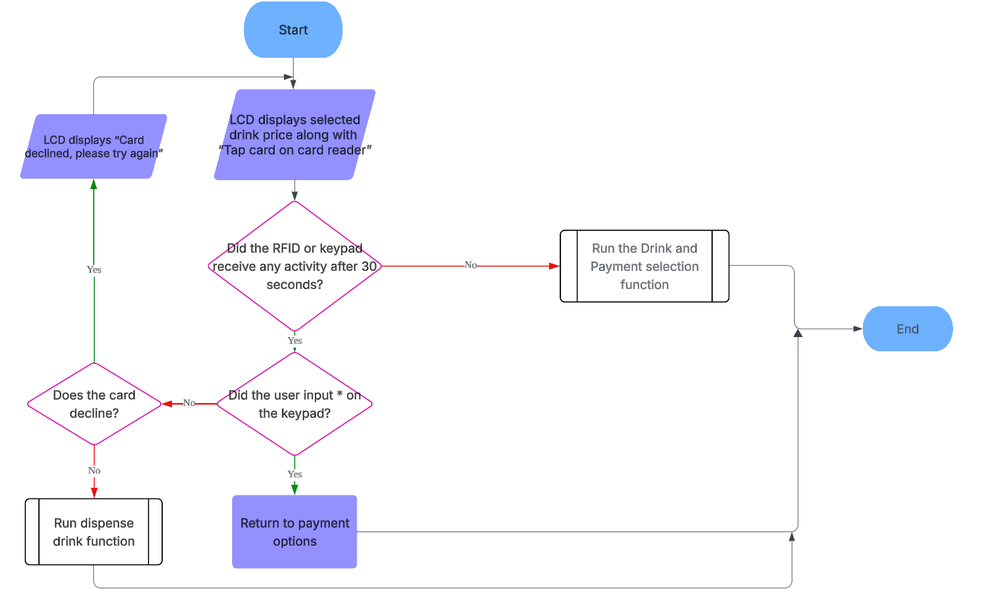
REQ-7
REQ-8
REQ-9
REQ-10
    - Function for QR code payment
The QR Code Payment function lets users pay by scanning a QR code, with LCD prompts and status updates. It processes payments, handles declines, allows cancellation, and resets after 30 seconds of inactivity.

REQ_ID | Requirement
REQ-11 | Once QR Code Payment is selected, LCD displays selected drink price along with “Please show QR” on line 1 and “code to camera” on line 2.
REQ-12 | Selected drink price will be requested to be deducted from the account linked to the QR code shown by the user
REQ-13 | If the user confirms the payment request,the selected drink price will be deducted from the account.
REQ-14 | If the user declines the payment request, LCD displays “Payment” on line 1 and “declined” on line 2. After 3 seconds, LCD returns to payment options screen
REQ-15 | If no payment is made after 30 seconds, return to homescreen
REQ-16 | Inputting * on keypad returns LCD to payment options screen

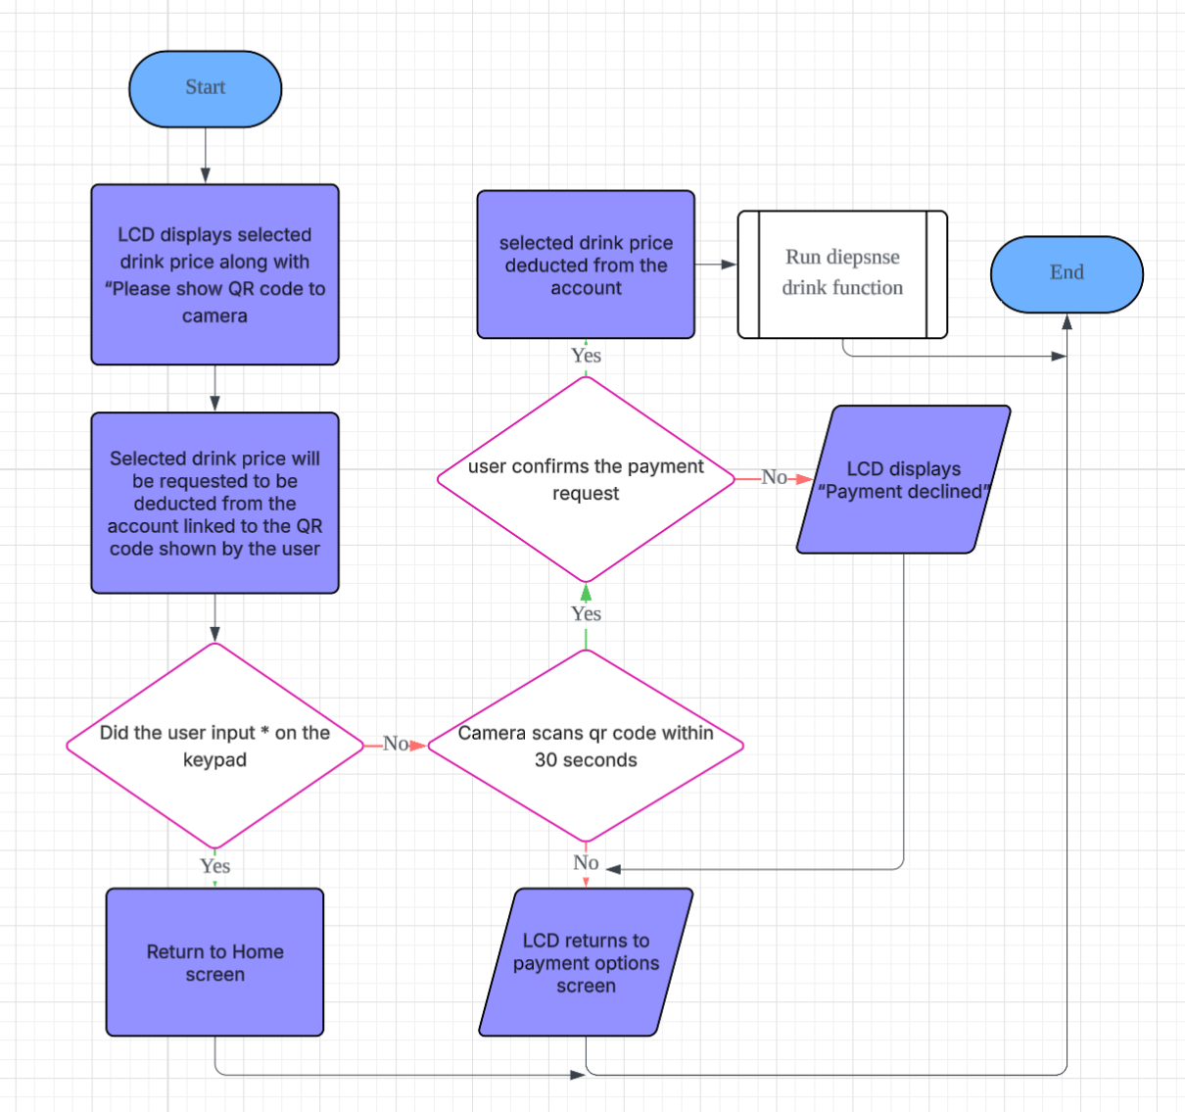
REQ-11
REQ-12
REQ-13
REQ-14
REQ-15
REQ-16

Function for Monitoring Temperature Conditions
The Monitoring Temperature function checks internal temperature, alerts staff by email, disables purchases at critical levels, and activates warnings while allowing ongoing user transactions before shutdown.

REQ_ID | Requirement
REQ-17 | If the internal temperature of the vending machine goes above 10°C, the staff will be alerted via Email saying "Temperature is above 10°C" once. Temperature is measured constantly
REQ-18 | If the temperature hits 20°C or above,users are prevented from buying drinks and LCD displays “Machine out” on line 1 and “of order” on line 2. LED also blinks at 2Hz. The staff will receive an alert via Email saying “Temperature is above 20°C, Machine is Disabled” once.
REQ-19 | If user is interacting with the vending machine, even while the temperature hits 20°C or above, they cannot be prevented from buying drinks and the LED will not blink until the vending machine receives no user input for 30 seconds.
REQ-NEW | Temperature is constantly monitored

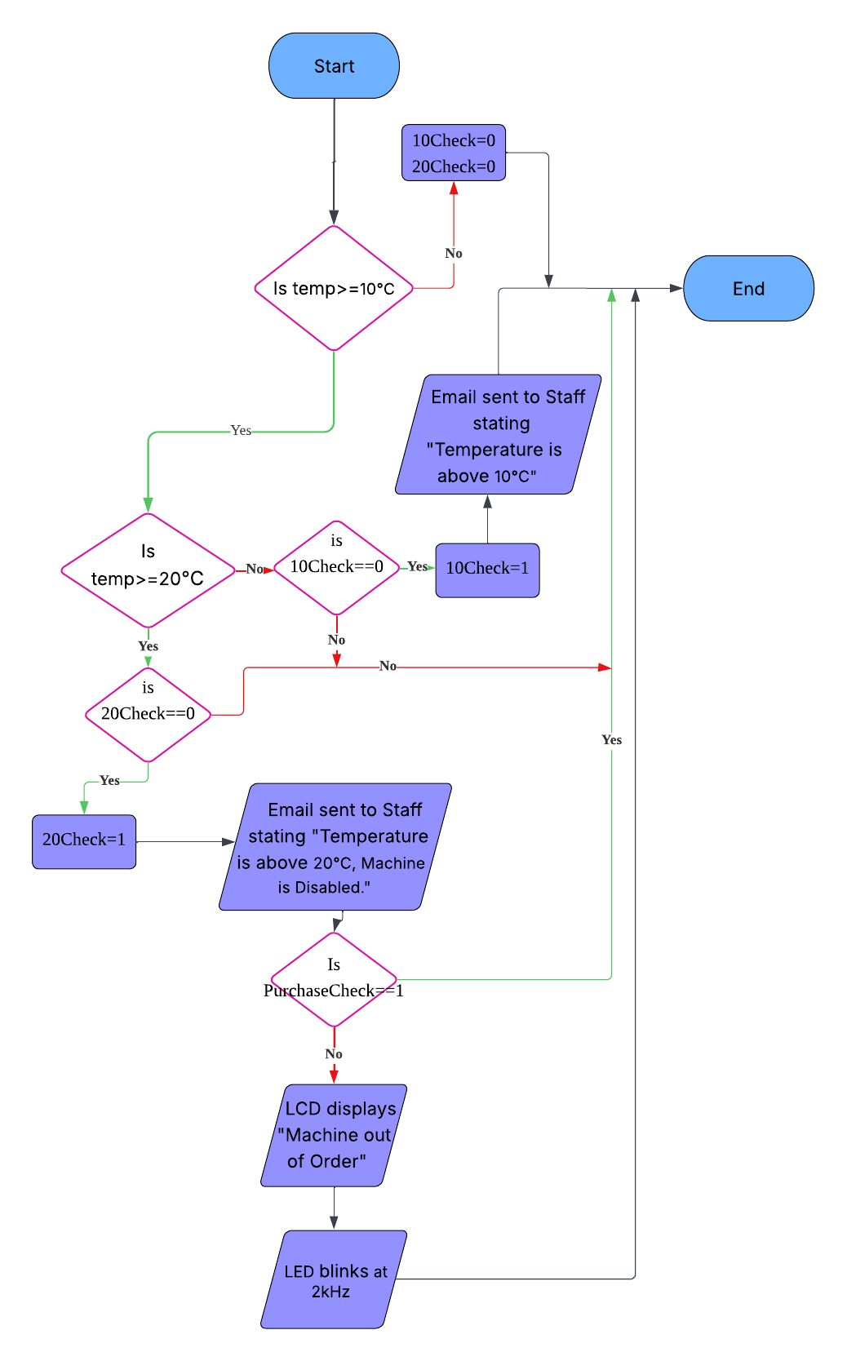
Req-17
REQ-18
REQ-19

Function for dispensing drinks
The Dispensing Drinks function releases the selected drink after payment, updates stock levels, and shows status updates on the LCD.
REQ_ID | Requirement
REQ-20 | After payment has been made, the LCD displays "Payment made,” on line 1 and “dispensing drink" on line 2.
REQ-21 | Only after payment is made, the DC motor pushes the selected drink from the vending machine’s drink storage, causing it to drop down to the collection point for users to take.
REQ-22 | The vending machine shall track the stock levels of each drink, after each drink is dispensed, stock for the corresponding drink would be reduced by 1. The information shall be recorded and updated within the vending machine’s internal inventory system.
REQ-NEW | The internal inventory system shall be cross-checked with the measured drink stock from the stock monitoring system.  If the internal inventory stock is less than the stock monitoring stock, an email will be sent to the staff saying “Vending Machine Jammed”.  If the stock monitoring stock is less than the internal inventory stock, an email will be sent to the staff saying “Extra drink dispensed”.S

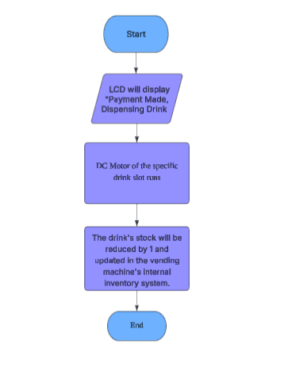
REQ-20
REQ-21
REQ-22
    - Function for admin access
Admin Access lets authorized users disable the burglar system with a passcode, reactivates on door close, and triggers alerts if the door stays open over 3 minutes, silenced by door close or keypad press.

REQ_ID | Requirement
REQ-23 | When a specific passcode is typed into the keypad, the burglar detection system is disabled, servo motor turn to 90
REQ-24 | When the door is closed, i.e. the IR sensor does not detect light, the burglar detection system is reactivated. i.e. the IR sensor is no longer overwritten
REQ-25* | When the door is opened for more than 3 minutes, the buzzer starts beeping at 2 KHz and the LCD displays “Still there?” on line 1, and “Click Anything” on line 2
REQ-26* | Buzzer and LCD would stop its function if the door is closed or when password is pressed, the 3 minute timer would reset.
REQ-NEW | If it buzzes for 15 seconds, servo motor will turn back to 0, i.e. door closed, LCD displays “Locking Door” on line 1
REQ-NEW | If admin closes door at any time, LCD displays “Locking Door” on line 1 and door closes

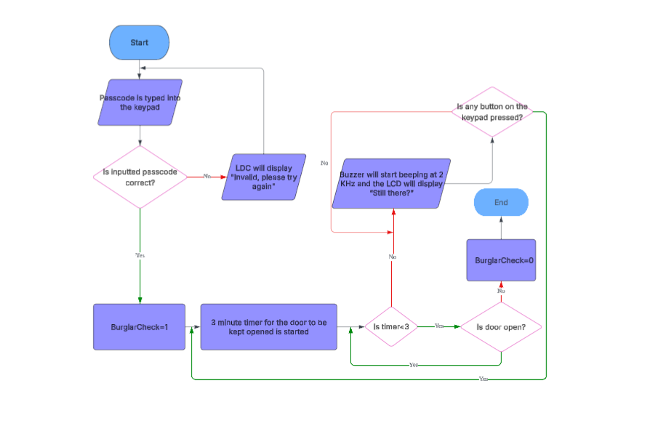
REQ-23
REQ=24
REQ-25
REQ-26

    - Function for Stock Monitoring
Stock Monitoring tracks inventory with counters and an ultrasonic sensor, alerts staff when stock is low, and blocks selection of out-of-stock drinks.

REQ_ID | Requirement
REQ-27 | If the stock for any drink is below 5, an alert shall be sent to the staff via Email
REQ-28 | As an extra precaution, an ultrasonic sensor will be positioned at the back of the drink section. It measures the distance to the nearest drink from behind, when the distance is short, it indicates that stock is high. When the distance increases, it means the section is running low.
REQ-29 | When stock for any drink reaches 0, it would update the system to prevent users from selecting the drink.
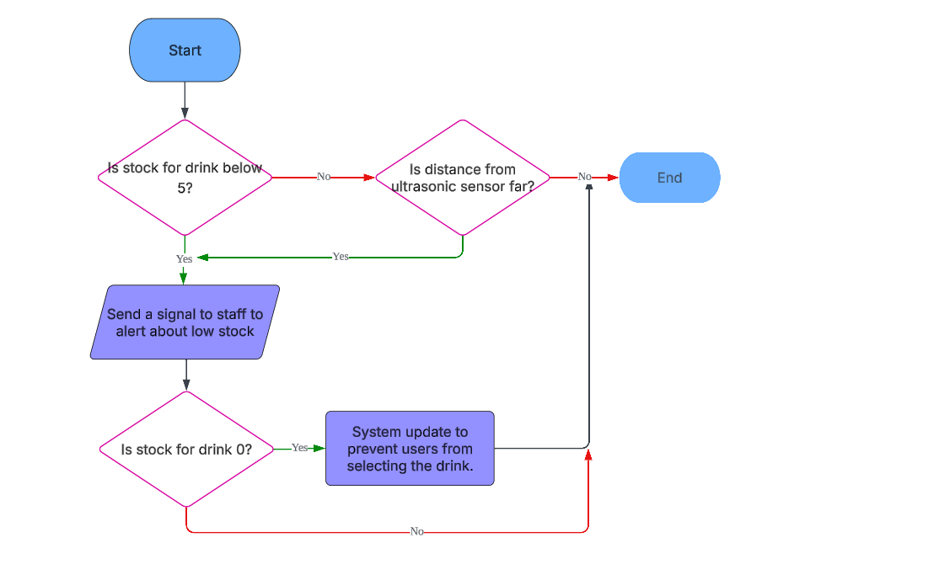
REQ-29
REQ-27
REQ-28

    - Function for burglar detection system
The Burglar Detection System uses an IR sensor to detect forced entry, triggers an alarm, captures images, and emails them to staff.
REQ_ID | Requirement
REQ-30 | If the vending machine door is forcefully pried open i.e. IR sensor detects light, without the correct passcode entered on the keypad, safety protocols will be activated. The IR sensor placed beside the door will detect any sudden change in light intensity, instantly activating these safety measures.
REQ-31 | If the machine door is pried open, buzzer and LED will be activated and images of the vending machine’s surroundings will be captured and sent to the staff via email.

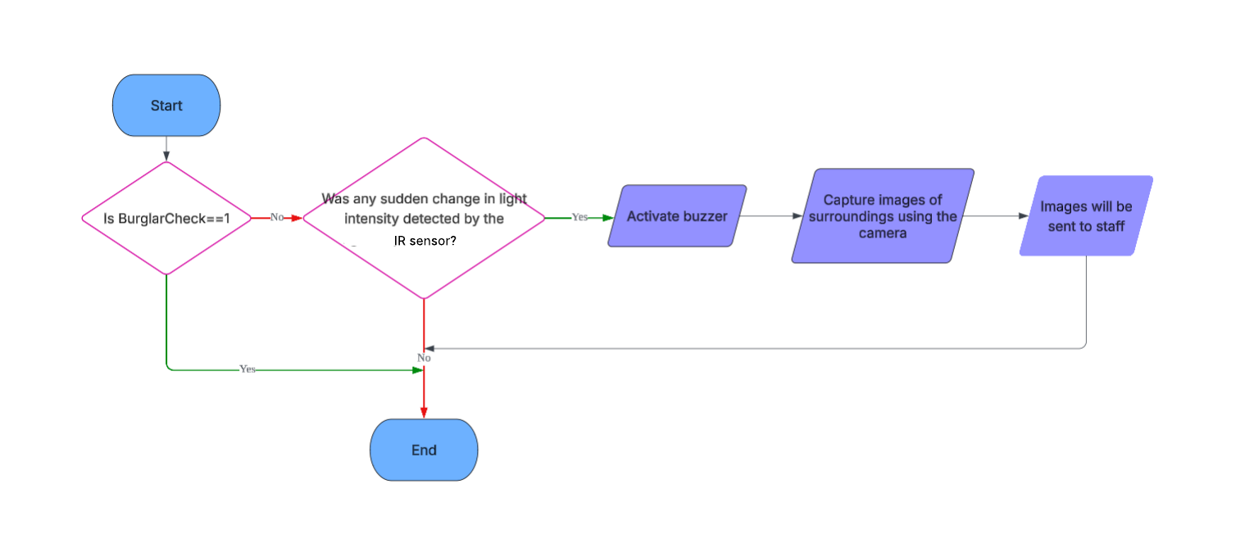
REQ-30
REQ-31

Function for Monitoring Liquid Leakage
The Liquid Leakage function detects leaks via a moisture sensor, alerts staff, disables purchases, and activates warnings—delaying lockout until 30 seconds after user inactivity.

REQ_ID | Requirement
REQ-32 | A moisture sensor will be attached to the base of the vending machine. If there is a leak in the drinks, the moisture sensor will detect it and send an alert to the staff via Email. Users are prevented from buying drinks and LCD displays “Machine out” on line 1 and “of order” on line 2. LED also blinks at 2 Hz.
REQ-33 | If user is interacting with the vending machine, even if there is detection, they cannot be prevented from buying drinks and the LED will not blink until the vending machine receives no user input for 30 seconds.
REQ-NEW | Moisture is constantly monitored
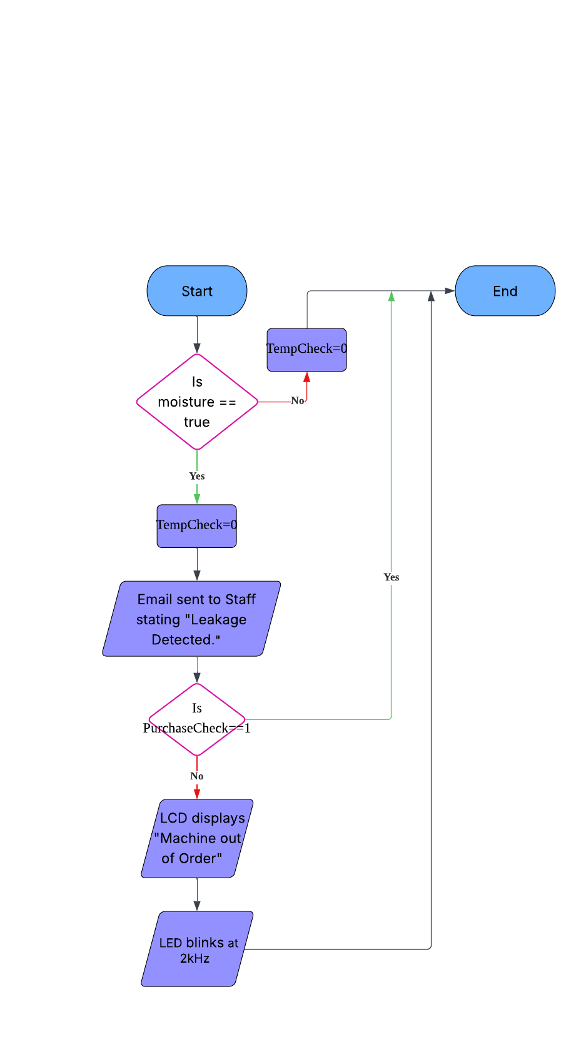
REQ-32
REQ-33

Function for User API
The app lets users sign up or log in with a username and password. After login, users can view real-time drink menus, make payments, receive a code collection.

REQ_ID | Requirement
REQ-34 | The homepage for “User Interface” should have 2 buttons “Login” and “Sign Up”
REQ-35 | After clicking “Sign Up”, users would provide inputs for 2 textboxes for “Username” and “Password” respectively. There would also be a button for “Create” once they are done with the inputs
REQ-36 | After clicking “Create”,if any textbox is empty, there would be red words under the “Create” button, stating “Username or Password Field can’t be blank.”
REQ-37 | After clicking “Create”, if the “Username” textbox is the same as any previous account, there would be red words under the “Create” button, stating “Username already taken.”
REQ-38 | After clicking “Create”, if it passes REQ-36 & 37, the account would be created and logged in automatically and show the drink menu. Username and Password added to database
REQ-39 | After clicking “Login”, users would provide 2 textboxes for “Username” and “Password” respectively. There would also be a button for “Enter”
REQ-40 | After clicking “Enter”, if the “Username” and “Password” don't match, there would be red words under the “Enter” button, stating “Wrong Username/Password”. Otherwise, it would login and show the drink menu.
REQ-41 | The mobile app shall allow users to view real-time drink menus from a connected vending machine and a purchase button for available drinks
REQ-42 | After successful payment, the app shall generate a unique 5 digit code for collection.
REQ-43 | The database will also subtract 1 drink from respective drink stock after purchase.
REQ-44 | Once the 5 digit code is used once, it will be deleted from the database to prevent extra drink dispensing

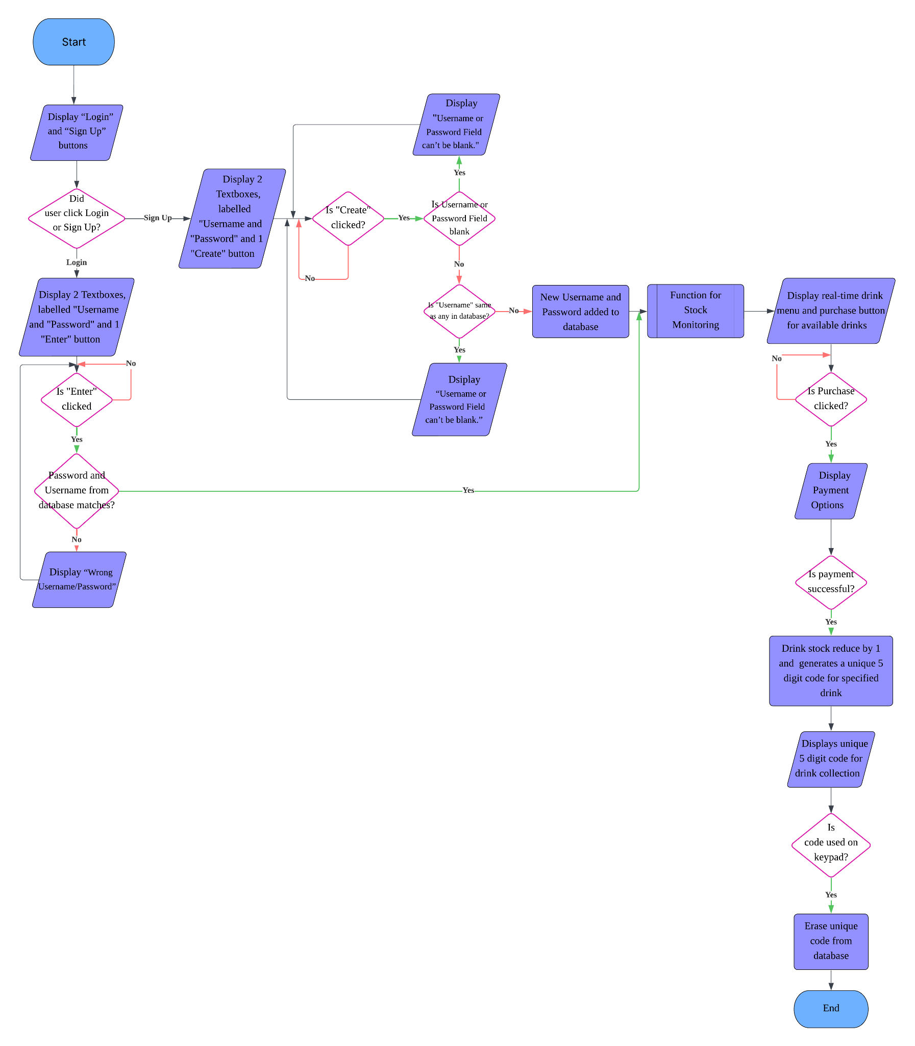
REQ-34
REQ-35
REQ-36
REQ-37
REQ-38
REQ-42
REQ-44
REQ-43
REQ-39
REQ-40
REQ-41

Non-Functional Requirements

Drink dispensing speed
Add short description here …

REQ_ID | Requirement
REQ-45 | The drink should be dispensed within 5 seconds of payment

    - Vending Machine initialisation duration
Add short description here …
REQ_ID | Requirement
REQ-46 | The machine shall fully initialise and be ready for operation within 15 seconds after turning on

    - Data privacy
Add short description here …
REQ_ID | Requirement
REQ-47 | User payment data will not be locally stored in the vending machine
REQ-48 | Data transmission between Vending Machine and external services must be encrypted using industry-standard protocols such as HTTPS.

    - Admin access security
Add short description here …
REQ_ID | Requirement
REQ-50 | The passcode for the vending machine’s admin access cannot be the same as any of the drink selections

    - Notification Delivery Time
Add short description here …
REQ_ID | Requirement
REQ-51 | Alerts shall be sent to staff within 1 minute of the burglar detection system being triggered.

    - Scalability
Add short description here …
REQ_ID | Requirement
REQ-52 | The system should allow the staff to add up to 50 drink options without modification to the core software.

    - User interface update
Add short description here …
REQ_ID | Requirement
REQ-53 | The keypad shall register the user’s input within 0.2 seconds
REQ-54 | The LCD will update within 0.5 seconds of receiving an input

    - Locking mechanism durability
Add short description here …
REQ_ID | Requirement
REQ-55 | The Vending Machine’s door lock should be strong enough to withstand a strong pull from users

    - Locking mechanism durability
Add short description here …
REQ_ID | Requirement
REQ-56 | The Vending Machine’s door lock should be strong enough to withstand a strong pull from users

Software Architecture

Static Software Architecture

The Software Architecture defines the various Software Components that are developed to realize the implementation of the system requirements.

LCD
USonic
NFC
Servo
Moisture sensor
card payment
dispensing drinks
IR sensor
buzzer
Dc motor
input_switch
Keypad
LED
QR code payment
Burglar detection system
Stock monitoring
Main menu
Monitoring temperature conditions
Admin access
Monitoring liquid leakage
Application Layer
Hardware Abstraction Layer (HAL)
User API
Camera
WiFi Module

